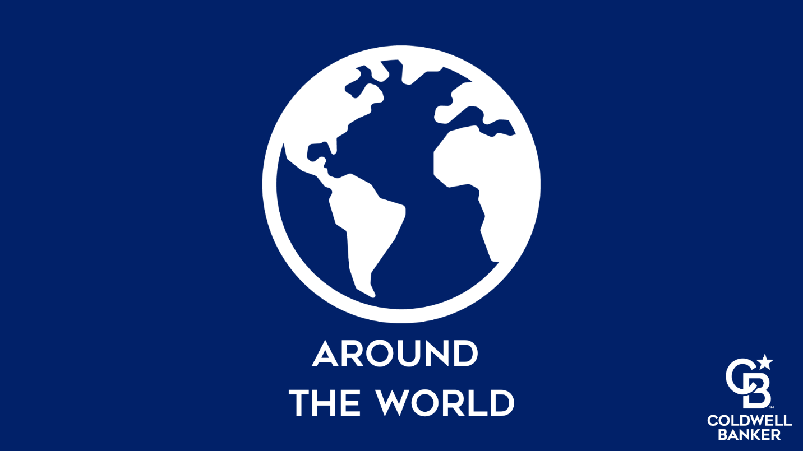
Thank you for agreeing to participate in the International Blog. Once the article is accepted, it will be posted on the Blue Matter Blog and other Coldwell Banker social media channels.
Please answer the following questions in English:
- Where do you live?
- What is the perfect weekend day like there?
- How do people move around the area, transportation?
- Tell us about the foods your area is known for.
- What is your favorite meal in your region? At home or at a restaurant?
- Where do you recommend someone vacation in your region, why?
- What is your favorite recreational or leisure time activity in your region?
- Is there a specialty (product, service, etc., that your region is known for)?
- Share a little known but interesting fact about the area/region.
- If you were to live in any other region where we have a Coldwell Banker presence, where would it be and why?

Please tell us a little bit about your region:
Territory Summary: (Mix of economics, history, geography)

Key Facts:
Population
Language spoken
Climate
Currency

Please tell us a little bit about the real estate industry in your region
Types of architecture
Prices per sq. ft/meter
Average Sale Price
Average years in house/apt
Types of financing

Something else interesting like type of ownership: fee simple, tenancy, etc. and/or average years in dwelling

Please provide two (2) separate quotes form folks that are pertinent to the article:
- Quote:
Full Name, Full Title, what is their role with Coldwell Banker?
- Quote:
Full Name, Full Title, what is their role with Coldwell Banker?

Please provide the Social Media Handles for Regional Office or Franchisee highlighted above. (Do NOT provide personal Social Media Handles.)
Facebook:
Twitter:
Instagram:
LinkedIn:

Please only provide a high-resolution image that you own to accompany your interview. It should be reflective of your region.

Thank you for returning this form to kait.mcmurdo@anywhere.re

